**Activation Functions and Loss Functions in Deep Learning: Differences and Overlaps**

[[Everton Gomede, PhD](https://medium.com/@evertongomede?source=post_page-----e62249de999d--------------------------------)](https://medium.com/@evertongomede?source=post_page-----e62249de999d--------------------------------)

[Everton Gomede, PhD](https://medium.com/@evertongomede?source=post_page-----e62249de999d--------------------------------)

·

[Follow](https://medium.com/m/signin?actionUrl=https%3A%2F%2Fmedium.com%2F_%2Fsubscribe%2Fuser%2Fb1a64eb107f0&operation=register&redirect=https%3A%2F%2Fmedium.com%2F%40evertongomede%2Factivation-functions-and-loss-functions-in-deep-learning-differences-and-overlaps-e62249de999d&user=Everton+Gomede%2C+PhD&userId=b1a64eb107f0&source=post_page-b1a64eb107f0----e62249de999d---------------------post_header-----------)

5 min read

·

Oct 9, 2023

79

**Introduction**

Deep learning has revolutionized various fields of artificial intelligence, enabling machines to perform complex tasks with remarkable accuracy. Two fundamental components in the architecture of deep neural networks are activation functions and loss functions. Activation functions introduce non-linearity into the model, while loss functions quantify the model’s performance during training. This essay explores the differences and overlaps between activation and loss functions, highlighting their crucial roles in the success of deep learning models.



*Activation functions are the brushes that add strokes of non-linearity to the canvas of neural networks, while loss functions serve as the compass guiding the artist’s quest for the perfect masterpiece. In the world of deep learning, these tools harmonize their differences and overlap in purpose to create intelligence from raw data.*

**Activation Functions**

Activation functions serve as the building blocks of deep neural networks. They are applied to the weighted sum of inputs to introduce non-linearity, which enables neural networks to learn complex relationships in data. There are several types of activation functions, each with its own characteristics:

1. **Sigmoid**: The sigmoid function maps input values to the range (0, 1), making it suitable for binary classification tasks. However, it suffers from the vanishing gradient problem, which can slow down training.
2. **Tanh (Hyperbolic Tangent):** Tanh is similar to the sigmoid but maps input values to (-1, 1), providing a better symmetry around zero. It also suffers from the vanishing gradient problem.
3. **ReLU (Rectified Linear Unit):** ReLU is one of the most widely used activation functions. It is computationally efficient and overcomes the vanishing gradient problem. However, it is susceptible to the dying ReLU problem, where neurons can become inactive during training.
4. **Leaky ReLU:** Leaky ReLU addresses the dying ReLU problem by allowing a small gradient for negative input values, preventing neurons from becoming entirely inactive.
5. **Parametric ReLU (PReLU):** PReLU takes the idea of Leaky ReLU a step further by allowing the gradient to be learned during training, rather than being a fixed parameter.
6. **Swish**: Swish is a smooth and differentiable activation function that has gained popularity due to its improved performance in some scenarios.

**Loss Functions**

Loss functions, also known as cost functions or objective functions, measure the difference between the predicted outputs of a model and the actual target values. The choice of the loss function depends on the type of task a neural network is designed for:

1. **Mean Squared Error (MSE):**MSE is commonly used for regression tasks. It computes the average squared difference between predicted and actual values. The goal is to minimize this error.
2. **Cross-Entropy Loss:** Cross-entropy loss is widely used for classification tasks. It measures the dissimilarity between predicted class probabilities and true class labels. Cross-entropy encourages the model to assign higher probabilities to the correct class.
3. **Hinge Loss:**Hinge loss is often used for support vector machines (SVMs) and some types of binary classification problems. It aims to maximize the margin between classes.
4. **Categorical Cross-Entropy:** Similar to cross-entropy loss, this variant is used for multi-class classification problems. It measures the divergence between predicted class probabilities and one-hot encoded target labels.

**Differences and Overlaps**

While activation functions and loss functions serve distinct purposes in deep learning, they are interconnected in the training process:

1. Activation functions introduce non-linearity into neural networks, enabling them to model complex relationships. In contrast, loss functions quantify the error or dissimilarity between predicted and actual values.
2. Activation functions are applied at each neuron in the hidden layers of a neural network, ensuring that the network can learn non-linear mappings of data. Loss functions, on the other hand, are applied to the output layer and guide the network’s learning by penalizing incorrect predictions.
3. Activation functions are used to introduce non-linearity and enable the network to approximate complex functions, while loss functions are used to provide feedback to the network during training, helping it adjust its weights and biases to minimize the error.
4. Overlapping occurs when certain activation functions, like ReLU, are used in combination with specific loss functions, like mean squared error. This combination may lead to issues like exploding gradients, which can hinder training stability.

**Code**

Here’s an example of implementing activation functions and loss functions in deep learning using Python with plots. We’ll use the Matplotlib library to visualize the results. First, make sure you have Matplotlib installed:

pip install matplotlib

Now, let’s create Python code to demonstrate activation functions and loss functions with plots:

import numpy as np  
import matplotlib.pyplot as plt  
  
# Activation functions  
def sigmoid(x):  
 return 1 / (1 + np.exp(-x))  
  
def relu(x):  
 return np.maximum(0, x)  
  
def tanh(x):  
 return np.tanh(x)  
  
# Generate x values  
x = np.linspace(-5, 5, 100)  
  
# Compute activation functions  
sigmoid_output = sigmoid(x)  
relu_output = relu(x)  
tanh_output = tanh(x)  
  
# Plot activation functions  
plt.figure(figsize=(12, 5))  
  
plt.subplot(131)  
plt.title("Sigmoid Activation")  
plt.plot(x, sigmoid_output)  
plt.grid(True)  
  
plt.subplot(132)  
plt.title("ReLU Activation")  
plt.plot(x, relu_output)  
plt.grid(True)  
  
plt.subplot(133)  
plt.title("Tanh Activation")  
plt.plot(x, tanh_output)  
plt.grid(True)  
  
plt.tight_layout()  
plt.show()  
  
# Loss functions  
def mean_squared_error(y_true, y_pred):  
 return np.mean((y_true - y_pred) ** 2)  
  
def binary_cross_entropy(y_true, y_pred):  
 return -np.mean(y_true * np.log(y_pred) + (1 - y_true) * np.log(1 - y_pred))  
  
# Generate sample data  
y_true = np.array([1, 0, 1, 0, 1])  
y_pred = np.array([0.8, 0.2, 0.7, 0.1, 0.9])  
  
# Compute loss values  
mse_loss = mean_squared_error(y_true, y_pred)  
bce_loss = binary_cross_entropy(y_true, y_pred)  
  
# Plot loss functions  
plt.figure(figsize=(10, 4))  
  
plt.subplot(121)  
plt.title("Mean Squared Error Loss")  
plt.bar(["Sample"], [mse_loss])  
plt.grid(True)  
  
plt.subplot(122)  
plt.title("Binary Cross-Entropy Loss")  
plt.bar(["Sample"], [bce_loss])  
plt.grid(True)  
  
plt.tight_layout()  
plt.show()

This code defines three common activation functions (sigmoid, ReLU, and tanh) and two loss functions (mean squared error and binary cross-entropy). It then generates sample data and computes the activation outputs and loss values, plotting them using Matplotlib. You’ll see plots of the activation functions and bar graphs of the loss values for the given sample data.

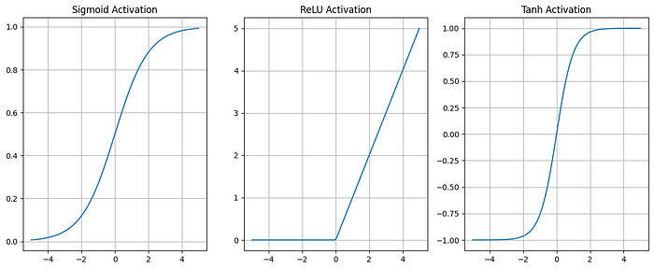

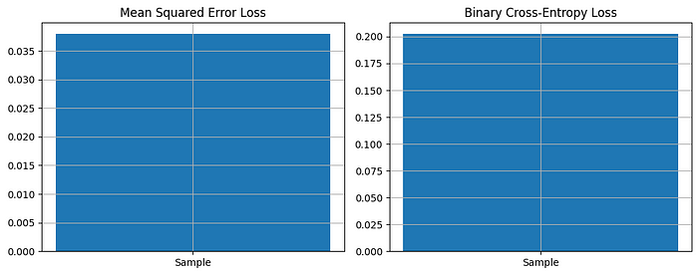

You can modify the activation functions, loss functions, and sample data to experiment with different scenarios and visualize their effects.

**Conclusion**

Activation functions and loss functions are essential components of deep neural networks, each with its distinct role and characteristics. Activation functions introduce non-linearity into the model, enabling it to capture complex patterns in data, while loss functions quantify the error between predictions and actual values, guiding the training process. While they serve different purposes, the choice of activation and loss functions can significantly impact the performance and training dynamics of deep learning models. Understanding their differences and overlaps is crucial for designing effective neural networks and achieving state-of-the-art results in various machine learning tasks.